**Piyush sharma/x17342356**

**User Guide**

**SAB**

**Sign up**

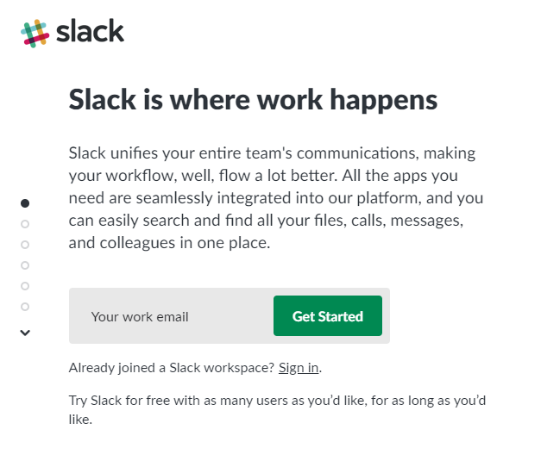

* The user is required to give an email.
* This email is verified by sending a code to the email.
* After email is verified you are required to give your full name and create a name for slack account.
* You are informed about each step and how to carry it out.

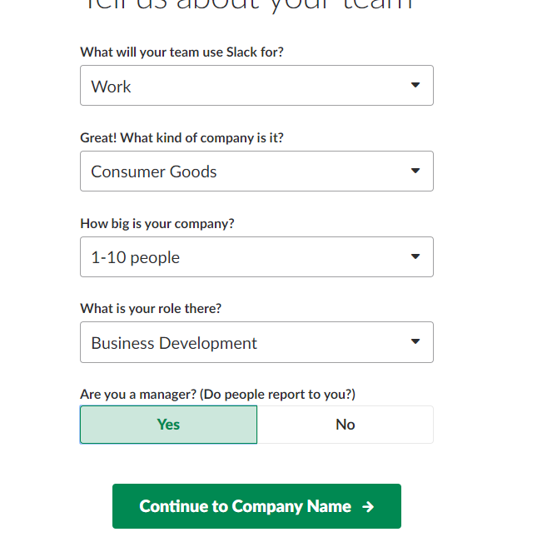

* Then the business is required to fill the following info in order to create an account.
* This step is mainly filled out by the manager as the manager needs to create an account and invite all the workers.

**Tool bar**



The toolbar allows the following tasks:

* Create channels (press the plus)
* View threads
* See the people in the group and weather they are active (green circle beside their name).
* It also allows the manager to invite people(Plus)
* It also allows apps to be added (plus).

**Group/individual messages**

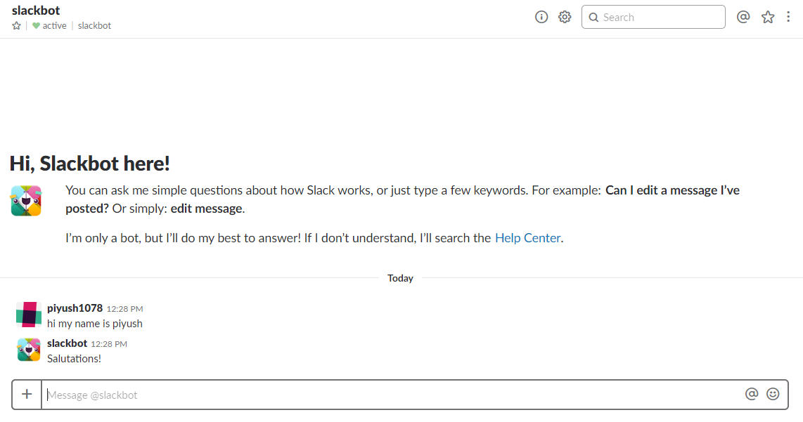

* Messages can be added to the group by typing them in the bar provided.
* All messages are saved so people are able to back track and check what has happened in the group chat.
* By clicking the plus on the tab, you can add files pictures….

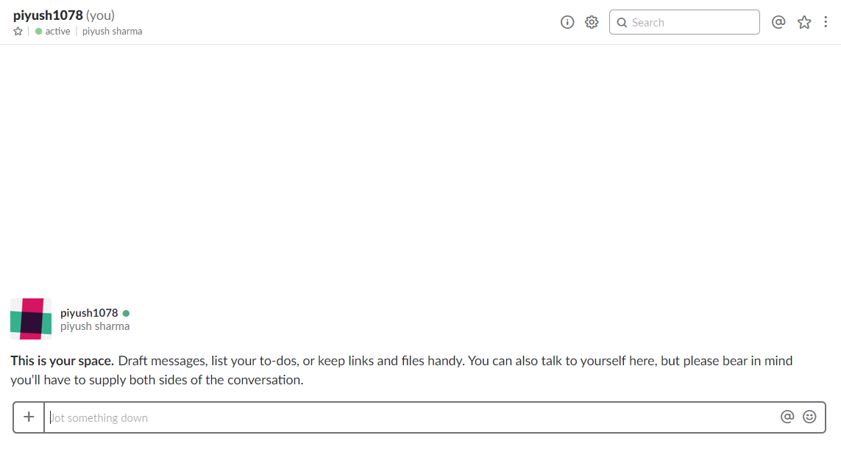

* Users can individually message each other by clicking the other users name on the tool bar.
* The following page appears.
* How to use the message page is mentioned above group messages.

**File access**

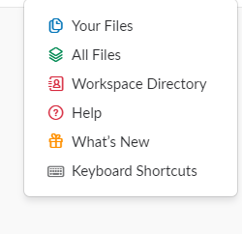

* This page appears on the top right of the screen when the three dots are clicked.
* This page allows one to access their files and workspace directory ect.

**Creating channels**

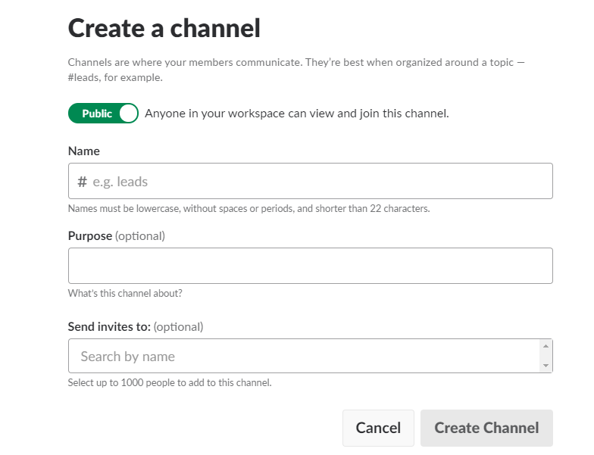

* This window pops up when you click plus on the channel option on the tool bar.
* This window allows new channels to be created.
* You can specify who is allowed to access the channels.
* Other specification options will be available.